**Small Meeting Room & Study Pod Use Policy**

The Library has two study rooms, the Lucy Siddall Small Meeting Room, located on the second floor of the library, and an individual Study Pod located on the first floor of the library. Both rooms are available free of charge during open library hours from 9 am until 30 minutes before closing. 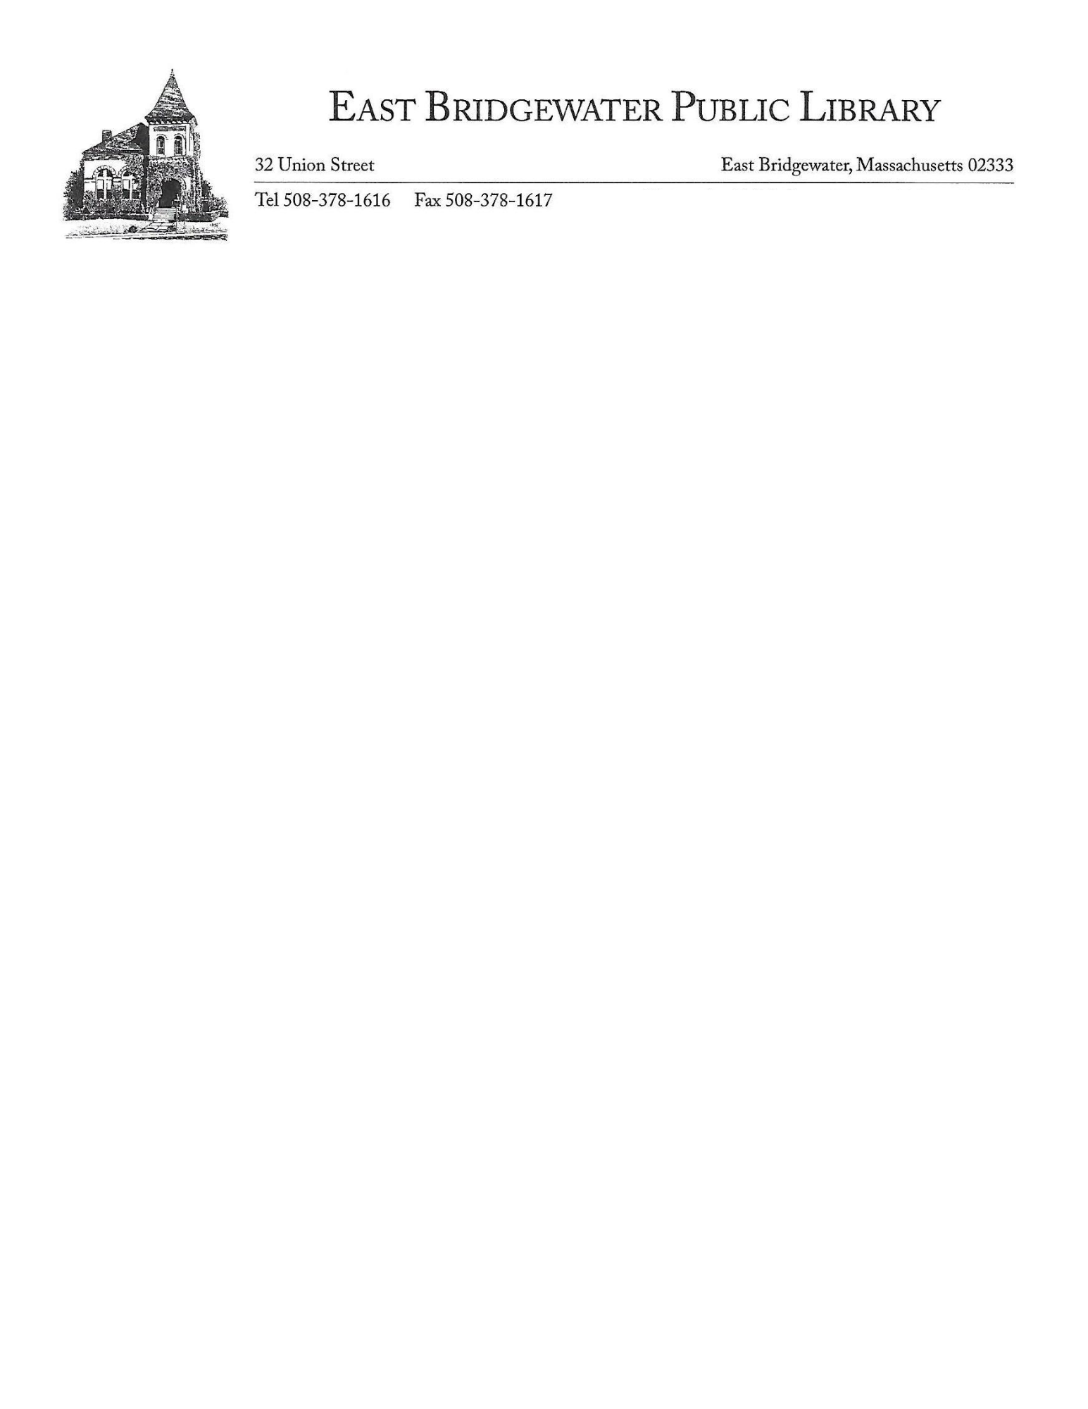

Persons using these spaces shall not sell or promote any material or service for private profit or gain, and are subject to all library policies including the Code of Behavior.

The library will not provide storage space for any individuals or groups and will not be responsible for items left unattended. The study spaces must be left in clean condition. Furniture may not be moved into or out of the study spaces. Users must not affix anything onto the walls or windows.

It is the library's intent to provide use of these spaces to as many people as possible. The library may limit uses per month, if necessary.

**Lucy Siddall Small Meeting Room**

The Lucy Siddall Small Meeting Room is intended for individual study, virtual meetings, and small group meetings. It is a semi-private space and relatively quiet. This room can accommodate eight people. Groups must not exceed this capacity. Use is intended for patrons ages 16+, and underage patrons with a responsible adult.

Individuals and groups may book the Lucy Siddall Small Meeting Room by making reservations in advance. Subject to availability, walk-ins are also welcome. Both walk-ins and users with reservations must check-in at the first floor Circulation Desk.

The room has a 2-hour time limit with extensions in 1 hour increments. There is a 15-minute grace period for reservations.

**Study Pod**

The Study Pod is intended for quick phone calls, individual study, and virtual appointments. It has sound dampening properties to allow for semi-privacy, and is located in the Millet Room, the library’s quiet study space. The Study Pod can accommodate one person. The Study Pod is available on a first come, first served basis without a reservation for quick use of up to 30 minutes. For use longer than 30 minutes, visitors should check-in at the first floor Circulation Desk.

Approved, Board of Library Trustees – 11/4/24